System Design Notes
A Structured Notebook for System Design
Source Repository: github.com/manishrnl/

About the Author
Manish
B.Tech (2022 – 26 ) , Computer Science (AI & System Design)

Portfolio: manishrnl.in
GitHub Repository: github.com/manishrnl/
This notebook compiles practice problems, patterns, and notes across core DSA modules — Bit Manipulation, Number Theory, Recursion, Backtracking, Arrays, Sorting, Searching, Hashing, and Heaps — built while preparing for SDE / Java Backend interviews.
You tube Channel I follow for this course is https://www.youtube.com/watch?v=SqcXvc3ZmRU&list=PLMCXHnjXnTnvo6alSjVkgxV-VH6EPyvoX

PLEASE OPEN THE PDF IN ”ADOBE ACROBAT” ONLY since other apps does not fully responds to the hyperlink inside this documents. I had tested it many times and so came to this conclusion. Thanks

Index
Module | Topic | LeetCode / Reference | Page
00. Introduction | 0.1 Introduction to System Design | LC 509 - Fibonacci numbers | 01 →
 | 0.2 HLD and LLD Design | LC 50 , LC 326 | 02 →
 | 0.3 Time Complexity via Recursion Tree method | LC 148: Sort List, LC 22 | 03 →
 | 0.4 Time Complexity via Master Theorem | LC 23: Merge k Sorted Lists, LC 240 | 05 →
 | 0.5 About 10⁸ Rule | LC 01 Two Sum | 06 →
 | 0.6 Bit Masking – A Grace to Computing fields | LC 191, LC 136, LC 78 | 07 →
 | 0.7 ( Blank pages for extra Notes) | — | 10 →
01. Bit Manipulation | 1.1 One Non-Repeating ,others appear twice | LC 136 - Single Number | 11 →
 | 1.2 Two Non-Repeating ,others appear twice | LC 260 - Single Number III | 13 →
 | 1.3 Find Single Element , Others Repeat Thrice | LC 137 - Single Number II | 15 →
 | 1.4 ( Blank pages for extra Bit Manipulation notes) | — | 17 →
02. Number Theory | 2.1 Fast / Modular Exponentiation (Calculate Power) | LC 50 - Pow(x, n) | 19 →
 | 2.2 Catalan Numbers (BST count, valid parentheses) | LC 96 - Unique BST | 21→
 | 2.3 Factorial (Iterative / Recursive) | GfG - Factorial of a Number | 23 →
 | 2.4 GCD / HCF of 2 Numbers (Euclidean Algorithm) | LC 1979 - Find GCD of Array | 24 →
 | 2.5 Inclusion-Exclusion Principle | GfG - Incl-Exc Principle | 25 →
 | 2.6 Palindrome Check (Number) | LC 9 - Palindrome Number | 27 →
 | 2.7 Pigeonhole Principle Examples | GfG - Pigeonhole Principle | 28 →
 | 2.8 Prime Numbers (Sieve of Eratosthenes) | LC 204 - Count Primes | 30 →
 | 2.9 Count Trailing Zeroes in Factorial | LC 172 - Factorial Trailing 0’s | 31 →
 | 2.10 ( Blank pages for extra Number Theory notes ) | — | 32 →
03. Recursion | 3.1 Josephus Problem | GfG - Josephus Problem | 33 →
 | 3.2 Permutations of an Array / String | LC 46 - Permutations | 34 →
 | 3.3 Power Set (Subsets via Recursion) | LC 78 - Subsets | 35 →
 | 3.4 String Palindrome (Recursive Check) | LC 125 - Valid Palindrome | 36 →
 | 3.5 Unique Paths (Recursive Grid Traversal) | LC 62 - Unique Paths | 37 →
 | 3.6 (Blank pages for extra Recursion notes) | — | 38 →
04. Backtracking | 4.1 N-Queens Problem | LC 51 - N-Queens | 39 →
 | 4.2 Sudoku Solver | LC 37 - Sudoku Solver | 41 →
 | 4.3 (Blank pages for extra Backtracking notes) | — | 43 →
05. Array | 5.1 Majority Element (count > N/2) | LC 169 - Majority Element | 44 →
 | 5.2 Kadane's Algorithm (Maximum Subarray Sum) | LC 53 - Maximum Subarray | 45 →
 | 5.3 Trapping Rainwater Problem | LC 42 - Trapping Rain Water | 47 →
 | 5.4 Best Time to Buy and Sell Stock | LC 121 - Buy & Sell Stock | 49 →
 | 5.5 (Blank pages for extra Array notes) | — | 51 →
06. Sorting | 6.1 Bubble Sort | LC 912 - Sort an Array | 52 →
 | 6.2 Insertion Sort | LC 147 - Insertion Sort List | 54 →
 | 6.3 Selection Sort | LC 912 - Sort an Array | 55 →
 | 6.4 Merge Sort | LC 148 - Merge Sort | 57 →
 | 6.5 Quick Sort | LC 912 - Sort an Array | 60 →
 | 6.6 (Blank pages for extra Sorting notes) | — | 62 →
07. Searching | 7.1 Binary Search | LC 704 - Binary Search | 63 →
 | 7.2 Allocate min no. of Pages (Google Interview) | LC 410 - Split Array Largest Sum | 65 →
 | 7.3 Linear Search | GfG - Linear Search | 67 →
 | 7.4 Search in an Infinite / Unbounded Sorted Array | LC 702 - Search in Unknown Size | 68 →
 | 7.5 Search in Sorted and Rotated Array | LC 33 - Search in Rotated Sorted Array | 70 →
 | 7.6 (Blank pages for extra Searching notes) | — | 72 →
08. Hashing | 8.1 Count Distinct Elements per Window of Size K | Count Distinct Elements per Window | 73 →
 | 8.2 Find All Distinct Elements in an Array | LC 1207 - Unique Number Occurrences | 75 →
 | 8.3 Intersection of Two Arrays | LC 217 - Contains Duplicate | 76 →
 |  | LC 349 - Intersection of Two Arrays
 | 8.4 Subarray with Given Sum | LC 560 - Subarray Sum Equals K | 77 →
 | 8.5 Union Two Arrays + Hashing Reports | GfG - Union of Two Arrays | 79 →
 |  | LC 706 - Design HashMap
 | 8.6 (Blank pages for extra Hashing notes) | — | 80 →
09. Heap (Priority Queue) | 9.1 Min Heap Implementation | LC 215 - Kth Largest Elements | 81 →
 | 9.2 Max Heap Implementation + Heap Reports | LC 1046 - Last Stone Weight | 84 →
 |  | LC 23 - Merge k Sorted Lists
 | 9.3 (Blank pages for extra Heap Notes) | — | 87 →

Module 0: Introduction ← Back to Index

0.1 Introduction to System Design

System Design is the process of defining the architecture, interfaces, modules, and data for a software system to satisfy specific business and technical requirements. At its core, system design is about managing trade-offs. There is rarely a single "correct" design; instead, it is about choosing the right tools, strategies, and patterns to solve a specific problem while balancing competing priorities like cost, speed, and reliability.

1. Why is System Design Important?
When building small, standalone applications, a single server and a basic database are usually enough. However, as user traffic grows from hundreds to millions of concurrent requests, systems hit physical limits.
Without proper system design, applications face major issues:
- The Single Point of Failure (SPOF): If your single server goes down, your entire business goes dark.
- Bottlenecks: A sudden spike in traffic causes a database to freeze up under the weight of too many read/write requests.
- Data Inconsistency: In a distributed setup, users might see outdated information if data takes too long to sync across servers.
System design provides the blueprint to handle massive scale gracefully, ensuring the application remains available, fast, and secure.

2. Core Pillars of System Design
When designing any large-scale system, architects evaluate the infrastructure based on four primary characteristics:

Scalability
Scalability is a system’s ability to handle an increasing amount of work by adding resources. There are two primary ways to scale:
- Vertical Scaling (Scaling Up): Adding more power (CPU, RAM, SSDs) to an existing server. It is easy to do but has a hard physical ceiling and introduces a single point of failure.
- Horizontal Scaling (Scaling Out): Adding more machines to your pool of resources. This is the foundation of modern cloud architecture, allowing systems to grow infinitely by distributing the load across hundreds of cheap servers.

Availability
Availability is the percentage of time a system remains operational and accessible over a given period. It is often measured in "nines" (e.g., 99.9% availability allows for roughly 8.7 hours of downtime per year, while 99.999% allows for only about 5 minutes). High availability is achieved through redundancy—having backup components ready to take over if a primary component fails.

Reliability
While availability means the system is up, reliability means the system performs its intended function correctly without dropping data or failing transactions. A reliable system handles errors, network drops, and hardware failures gracefully without corrupting user data.

Maintainability
Software is never finished. Maintainability ensures that the system is designed cleanly enough that new developers can understand it, bugs can be tracked easily, and new features can be added without breaking existing infrastructure. This is where modular architectures, clean APIs, and thorough documentation come into play.

3. Key Building Blocks of Distributed Systems
To achieve these pillars, system designers use a standard toolkit of architectural components:
- Load Balancers: Software or hardware mechanisms that sit in front of your servers and distribute incoming network traffic evenly across a cluster, ensuring no single server gets overwhelmed.
- Caching Layers (e.g., Redis, Memcached): Ultra-fast, in-memory storage used to hold frequently accessed data. Fetching data from a cache takes milliseconds compared to querying a heavy relational database.
- Databases: Choosing between Relational (SQL) databases (like PostgreSQL) for strict data integrity and complex relationships, versus Non-Relational (NoSQL) databases (like MongoDB or Cassandra) for unstructured data and massive write speeds.
- Asynchronous Messaging (e.g., Apache Kafka, RabbitMQ): Decoupling services by allowing them to communicate via events rather than direct API calls. If one service drops, the messages sit safely in a queue until it recovers.
- Content Delivery Networks (CDNs): A geographically distributed network of proxy servers that cache static content (like images and videos) close to end-users, drastically reducing latency.
The Golden Rule of System Design: PACELC Theorem In a distributed system that replicates data, you must choose your trade-offs. If there is a network Partition (a communication breakdown between servers), you must choose between Availability (A) or Consistency (C). Else, when the system is running normally, you must choose between Latency (L) or Consistency (C).
Understanding these fundamental trade-offs is what separates a junior developer from a system architect.

0.2 HLD and LLD Design ← Back to Index
Feature | High-Level Design (HLD) | Low-Level Design (LLD)
Focus | Overall system architecture and macro-view. | Component-level logic and micro-view.
Target Audience | System Architects, Product Managers, Stakeholders. | Developers, Code Reviewers, QA Engineers.
Key Questions | What components do we need and how do they talk to each other? | How do we implement the internal logic of this specific component?
Components | Services, Databases, Message Queues, CDNs, Load Balancers. | Classes, Interfaces, Methods, Design Patterns, Data Structures.
Design Tools | System architecture diagrams, data flow diagrams. | Class diagrams, sequence diagrams, database schemas.

1. High-Level Design (HLD)
HLD focuses on the big picture. It defines the entire system topology, major modules, and how data moves across network boundaries. At this stage, you aren't worried about individual lines of code; you're worried about scalability, reliability, and system bottlenecks.
Key Aspects of HLD:
- Microservices & Services: Deciding how to break down the application into functional blocks (e.g., Auth Service, Payment Service).
- Data Storage Strategy: Choosing relational databases (SQL) versus non-relational (NoSQL/Graph) based on read/write patterns, and planning for replication or sharding.
- Networking & Communication: Choosing between synchronous REST/gRPC or asynchronous event-driven messaging (e.g., Apache Kafka, RabbitMQ).
- Scalability & Performance: Introducing Load Balancers, Caching layers (like Redis), and Content Delivery Networks (CDNs).
2. Low-Level Design (LLD)
LLD zoom-ins on the individual modules defined in the HLD. It is highly technical and bridges the gap between a conceptual architecture and actual code. If the LLD is done well, a developer should be able to look at it and write the code directly.
Key Aspects of LLD:
- Object-Oriented Design (OOD): Defining the specific classes, abstract classes, interfaces, and their relationships (inheritance, encapsulation, polymorphism).
- Design Patterns: Applying standard software engineering solutions (e.g., Singleton, Factory, Strategy, or Observer patterns) to solve localized problems clean and efficiently.
- Database Schema Design: Mapping out exact table structures, primary/foreign keys, indexes, or specific graph entity relationships and constraints.
- Algorithms & Logic: Selecting precise data structures (e.g., HashMaps, Trees) and defining the step-by-step logic for complex methods or API endpoints.

0.3 Find Two Non-Repeating Elements (others appear twice) ← Back to Index

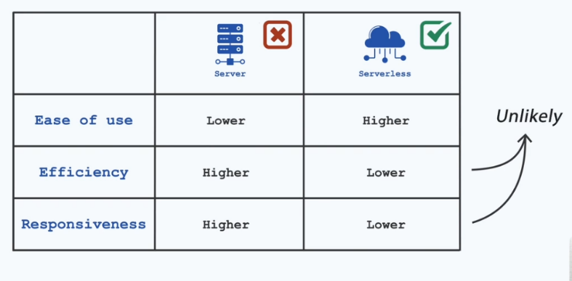
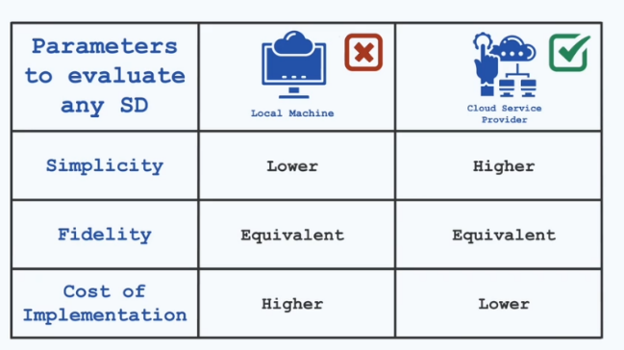

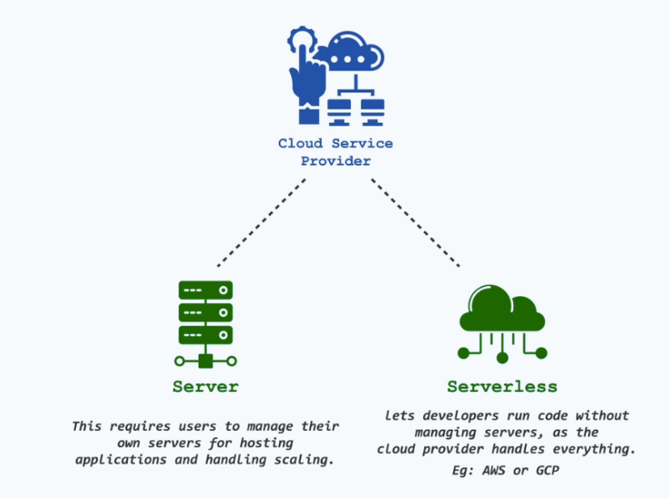

0.4 Find the Single Element When Others Repeat Thrice ← Back to Index

Problem Statement
Find the only non-repeating element in an array where every other element repeats thrice.
https://www.geeksforgeeks.org/dsa/find-unique-element-element-occurs-k-times-except-one/

Approach / Intuition

Code — Find the Single Element When Others Repeat Thrice

Notes if Any :

